December 19, 2003
Hockey Night with C.I.A. Services

It’s time for another Hockey Night in Houston with C.I.A. Services. This will be the sixth year we’ve invited our friends to enjoy a night on us watching the Houston Aeros – “the coolest guys downtown”. We’d love to have you and your guests join us for a fun night.


This year the date is Saturday, January 24th when we’ll see the Aeros battle a team from the North Division of the American Hockey League, the Syracuse Crunch (isn’t that a great name for a hockey team). The game is at the new downtown Toyota Center next to the George R. Brown Convention Center. Here’s your chance to see the inside of the new, state-of-the-art arena.

This is going to be an exciting game. As we approach mid-season, the Aeros have overcome their early struggles and are now on a 6 game winning streak (11-13-2-2*). Syracuse, with a couple former Aeros, has a similar record at 11-10-2-2* so we’re pretty evenly matched. With the style of play of both teams, this should be a classic hockey showdown.

Hockey is a cool, fun and fast-paced game. If you’ve never seen hockey in person, you are in for a treat. We’ll give you a nice guide to hockey that explains why you can smash someone up against the boards but can’t pass the puck the length of the ice. We’ll have a bunch of door prizes and other goodies. We have 400 great seats reserved behind the goal so we should see lots of action with Houston leading the league in shots on goal.

The game starts at 7:00 p.m. For those interested, we always pick a place to eat ahead of time. We’ll meet at Drexler’s World Famous BBQ before the game and may even have a visit by Clyde himself. You’ll want to get there by 5:30 p.m. or the rest of us will have all the tables taken! There will be several of us from C.I.A. Services handing out the game tickets at Drexler’s and then in front of the Toyota Center ticket windows from 6:30 p.m. until 7:15 p.m.

If you can join us, please RSVP no later than January 19th – the sooner the better since we expect the tickets to get claimed fast. Please let your Community Manager know or call our Southwest Office receptionist, Ms. Pat Kirk, at 713-981-9000. Give Pat your name, community and how many tickets you’d like. You can also email her at kirk@ciaservices.com.

This will be a lot of fun and I hope to see you there!
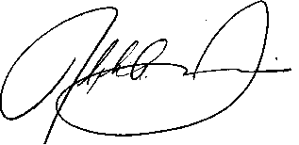
Ralph A. Troiano
President

* Wins, Losses, Ties & Overtime Losses
Toyota Center Drexler’s World Famous BBQ & Grill
1510 Polk Street 2300 Pierce
Houston, Texas 77002 Houston, Texas 77003
713-752-0008

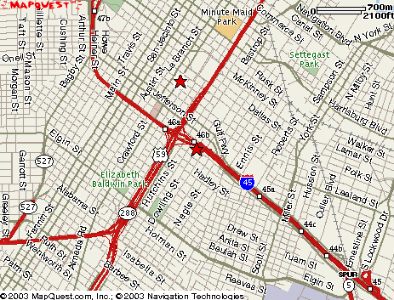

Reserve your tickets by calling Ms. Pat Kirk at 713-981-9000 or by email at kirk@ciaservices.com no later than 01/19/04. Only a limited number of tickets are available. Please do not reserve tickets unless you plan to use them.

C.I.A. Services staff will be handing out game tickets, door prize tokens and the hockey guide at Drexler’s BBQ before the game from 5:00 – 6:30 p.m. and in front of the Toyota Center ticket windows from 6:30 p.m. – 7:15 p.m. The game starts at 7:00 p.m. After 7:15 p.m., any unclaimed tickets will be left at the Toyota Center “Will Call” window.

Enjoy the game!

